TRAVEL TIPS FOR MALAYSIA

The cultural melting pot of Southeast Asia, Malaysia seamlessly blends the flavours of the Orient, India and Europe.
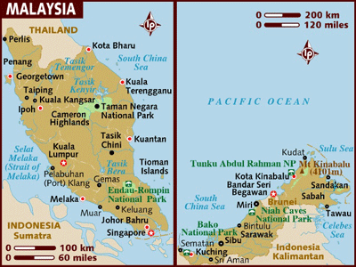

VISA The visa can be obtained prior as well as on arrival in the country

CLIMATE:
Malaysia is hot and humid all year so you're going to have sunshine and sweat pretty much whenever you visit. It is; however, best to avoid the November to January rainy season on Peninsula Malaysia's East Coast if you want to enjoy the beaches. The time to see turtles on the East Coast is between May and September.

Temperatures are usually between 20-30°C (68-86°F); humidity is usually 90 per cent. The region has a monsoon climate, but only the East Coast of Peninsular Malaysia has a real rainy season. The wettest season on the West Coast of the peninsula is between September and December; on the east coast and in Sabah and Sarawak it's between October and February. Rain, when it comes, generally interrupts the sunshine only briefly, most of it falls in short, strong bursts.

CURRENCY:
The Malaysian Ringitt (MYR) is the official currency here.

All major credit cards are accepted at upmarket hotels, shops and restaurants. If you have a credit card with a personal identification number (PIN) attached; you can obtain cash advances from ATM's. Banks in Malaysia are linking to international banking networks, which allow you to withdraw money from overseas savings accounts through ATM's. Check with your bank at home to see if you can withdraw money from your home account while in Malaysia.

HOW TO GET THERE:
By Air: There are 4 Direct Flights from India to Kuala Lumpur, viz., Air India, Indian Airlines, Jet Airways, & Malaysian Airlines.

GETTING AROUND:

Malaysian Airlines (MH) is the main domestic airline, servicing both the peninsula and Sabah and Sarawak. Fares are reasonable but it's unlikely that you'll need to fly in Peninsula Malaysia unless you're in a real hurry. It's cheaper to fly to East Malaysia from Johor Bahru than from KL. In East Malaysia, flying is often the only quick way to get around. Note that flights in East Malaysia are frequently fully booked during school holidays and are prone to delays due to the vagaries of the weather.

Peninsula Malaysia has a fast, economical and widespread bus system, and this is generally the best way to get around. Sabah has excellent roads, and minibuses ply the main routes. Buses ply Sarawak's major trunk road, but hardly anywhere else. Peninsula Malaysia has a comfortable and sensibly priced railway system, but there are basically only two lines: one linking Singapore to Thailand via KL and Butterworth, and the other branching off this at Gemas and heading north-east to Kota Bharu. In Sabah, there's a narrow-gauge line through the Pegas River gorge from Tenom to Kota Kinabalu, which is well worth catching.

In Peninsula Malaysia, long-distance taxis are twice the price of buses but they're a comparatively luxurious and efficient way to travel. If you want to get around by car, all major car-rental firms have KL offices. There are no boat services between Peninsula and East Malaysia, but fast boats ply the rivers of both Sabah and Sarawak.

Local taxis in Malaysia are metered. Rickshaws have all but disappeared in KL, but they are still a viable form of local transport in provincial areas. KL has a notoriously bad public transport system, and peak-hour travel in the city should be avoided at all cost.

ELECTRICITY:
The electrical current is 220-240 volts, AC 50Hz.

INFORMATION REGARDING THE MAJOR CITIES IN MALAYSIA:

KUALA LUMPUR

In 130 years, Kuala Lumpur has grown from nothing to a modern, bustling city of well over a million people. Superficially, KL (as it's almost universally known) may appear to be just another modern Asian city of gleaming skyscrapers, but it retains much of the character and local colour that has been so effectively wiped out in other Asian-boom cities such as Singapore. It has plenty of colonial buildings in its centre, a vibrant Chinatown with street vendors and night markets, and a bustling Little India.

MUST SEES:

Dataran Merdeka (Independence Square)

The official commemorative site of Malaysia's independence from colonial rule, visiting Dataran Merdeka is like stepping back in time.

The picturesque square is flanked by the mock-tudor Royal Selangor Club House (which still has an exclusively male suite) and cricket green, enduring reminders of the days of British government of the region. On the far side towers a 100m flagpole (claimed to be the highest in the world) and a quaint 19th-century English fountain. This was where the Union Jack finally came down on this particular slice of the British Empire.

The nearby cathedral of St Mary is a rare specimen of Gothic architecture, while beneath the square lies Plaza Putra and its collection of little shops, cafés and the Actor's Studio theatre and box office. A hub of life in the city, the square and its surroundings is a great place to get the musty flavour of colonial Britain.

Sultan Abdul Samad Buildings

This Kuala Lumpur icon was completed in 1897 and is a fusion of Moorish, Moghul and British architectural design.

Previously housing British colonial administration, the buildings now serves as a home to the Malaysian judiciary. The copper cupolas on the circular stair towers on the façade are impressive, while the arches give the building a South Mediterranean air. The building's old-fashioned charm goes a long way to usurping KL's more modern, and vastly more expensive motif, the Petronas Twin Towers. The old post office is connected to the buildings and features a similarly unusual style.

Petaling Street

This is the heart of Kuala Lumpur's Chinatown. Continuously teeming with activity, the shops along Petaling Street offer practically anything you may want to buy. Rummage your way through colourful textiles, herbal medicines, chewy pork floss, and even funeral accessories and hell money, to burn so that your dead ones can buy their way into heaven.

By early evening, the streets become one huge pedestrian mall with stalls selling watches, clothes, electronic goods, soft toys and everything else, propped higgledy-piggledy against each other. Neon lights and bright red lanterns strung from one side of the road to the other add to the festive atmosphere while the fragrant smell of bah kua (barbecued meat) permeates the air.

Sri Mahamariaman Temple
Jalan Tun H S Lee.

The oldest Hindu temple in Kuala Lumpur is adorned with a fascinating array of Hindu deities in solid colours reaching towards the sky.

The starting point of the annual Thaipusam procession, the temple is structured to imitate the points of the supine human body. Ladies in bright saris sit outside the door, weaving fragrant jasmine bunches. Make sure to remove your shoes before entering the temple.

Thean Hou Temple
65 Persiaran Endah, off Jalan Syed Putra

The Hainanese built this fascinating construction to pay tribute to the Goddess of the Sea. It's one of Southeast Asia's largest temples, with six ascending levels, an impressive multi-roofed entrance, ornately carved alabaster pillars, and numerous carvings of dragons.

With almost 700 icons of the goddess herself contained under the domed ceiling, sculptors somehow managed to squeeze in a few more deities. Look out for the Gods of Longevity, Wealth, Happiness and Prosperity among the statuary.
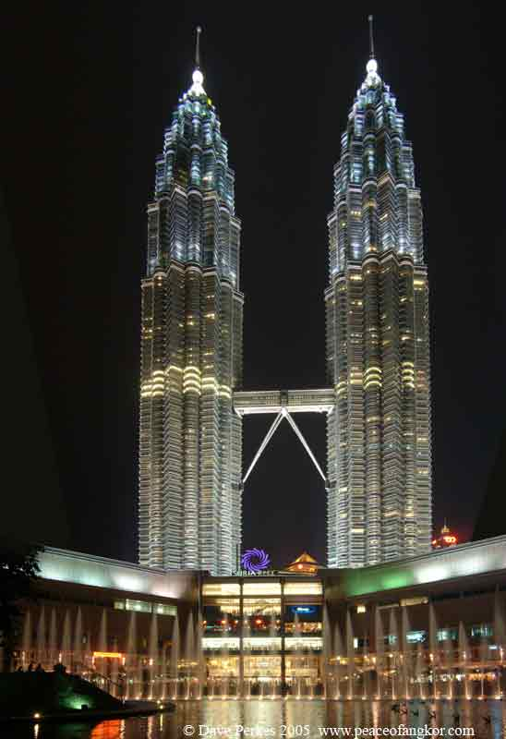
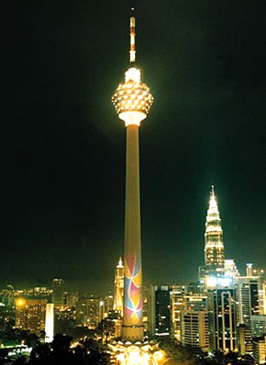

KL Tower
Jalan Puncak

Among the top ten tallest structures in the entire world (although not the tallest in Kuala Lumpur) it treats the tourist to a spectacular all-round view of Kuala Lumpur by day or night; and the viewing gallery comes in higher than the bridge on the king of the KL skyline, the Petronas Towers. Pick a clear day or night to play photographer or simply admire the view from the observation deck, then head to the revolving restaurant for light refreshments or a whacking good buffet.

Open: 0900 – 2200 hrs

Petronas Twin Towers

The world's third tallest towers at just shy of 452 metres, the Petronas Towers are a landmark of modern Kuala Lumpur.

The publicly accessible Skybridge is located between the 41st and 42nd floors, a "mere" 170 metres above ground level. It offers some tremendous views over the city, and the chance to see some of the world's most innovative architecture, from the inside. Queues may take a little time - and visitors should allow 45 minutes for a visit. Tickets are limited so come early or risk disappointment.

Open: Tue - Sun 0900 hrs – 1900 hrs
Closed for Friday prayers from 1300 hrs – 1430 hrs

Batu Caves

The Batu caves are over 440 million years old and are part of the most southerly outcrop of limestone in the world - meaning that their appearance is rather untypical of the landscape in this part of the world.

An important religious sight for Hindu believers, this is where the culmination of the Thaipusam procession from the Sri Mahamariaman temple takes place

MELAKA / MALACCA

Melaka is an interesting blend of Chinese, Portuguese, Dutch and British influences and is considered Malaysia's most historic city. It was once the most important trading port in the region but is now little more than a sleepy backwater. Ancient-looking junks still sail up the river, imbuing the waterfront with a timeless charm, and the city remains full of intriguing Chinese streets, antique shops, temples and nostalgic reminders of the now-departed European colonial powers.

The most imposing relic of the Dutch period in Melaka is the massive pink town hall, Stadthuys, built between 1641 and 1660. It's believed to be the oldest Dutch building in Asia and displays all the characteristic features of Dutch colonial architecture (read incredibly weighty doors and pleasant louvered windows). The building houses government offices and an excellent Ethnographic Museum, which highlights aspects of local history and culture. The imposing ruins of St Paul's Church, built by the Portuguese over 400 years ago, stand in a beautiful setting atop St Paul's Hill. It was regularly visited by St Francis Xavier, who was buried here for a short period before being transferred to Goa in India. The church fell into disuse when the Dutch arrived, but is still surrounded by Old Dutch tombstones. The Brits, with great sensitivity, used the church as a gunpowder store.

For those who prefer their religious architecture to be a little more colourful, the Cheng Hoon Teng Temple in the old part of the city is the oldest Chinese temple in Malaysia. It was founded in 1646, and all of the materials and all of the artisans who built it were imported from China. The old part of Melaka is a fascinating area to wander around, and this is where you'll find many of Melaka's famous antique shops; a stroll along Jalan Hang Jebat will pass the best of them.

PENANG

The 285 sq. km (177 sq. miles) island of Penang, off Peninsula Malaysia's northwestern coast, is the oldest British settlement in Malaysia and one of the country's premier resort areas.

MUST SEES:

Fort Cornwallis

Founded on the site of Francis Light's landing in 1786, Fort Cornwallis was built to guard the harbour against a French attack that never came. Apart from the still impressive outer walls there's not much else to see here. The fort is still guarded seawards by its cannon battery and although they have never been fired from Cornwallis some of the cannons have seen action elsewhere. Most famously among these is the Dutch cannon, first presented to the Sultan of Johore in 1606. It was later captured by Achenese pirates and found its way to Kuala Selangor from where the British removed it following another round of strenuous gunboat diplomacy in the 1870s. The largest cannon is called Seri Rambai and rather whimsically is believed to bestow fertility, hence the flowers laid in its muzzle by passing women. A small museum is located in what was once the magazine - and fills you in on these and other stories of the fort's life. After visiting the fort walk out onto the Esplanade, dotted with hawker foodstalls and sleepy colonial architecture.

Fort open: daily 0830 hrs – 1900 hrs

Chinatown

The Chinese have been a feature of Georgetown for as long as the city has been established, most seeking the riches on offer from the affluent freeport. Historically these exiles have concentrated in the mercantile area around Love Lane, Pitt Street and Carnarvon Street and the properties you'll see along these lanes are richly embellished with stucco relief and glazed tiles in the Chinese idiom. Most employ a characteristic design: shop at front, family home above and private courtyard behind. Take a stroll along these roads and keep your senses open to the vibrant, chaotic life of this community. Markets and restaurants flourish here - look out for Loke Thye Kee, the oldest eatery in Penang by some margin. Chinatown really comes to life at night when hawker stalls line the roads and markets burst out from shop fronts that were sleepily inactive during the day. Bring your appetite and walk along Chulia Street and Campbell Street where restaurants and bars proliferate. While in the area don't miss the gloriously ornate Khoo Kongsi Temple, a late Chang Dynasty masterpiece.

Open: daily 0900 hrs – 1700 hrs

Kek Lok Si Temple

The largest Buddhist temple in South-East Asia, Kek Lok Si is certainly the finest of Penang's many places of worship. The temple sits serenely atop a hill in Ayer Itam and is the centre point of a garden complex that is filled with sculptures, discreet shrines and a turtle pond. The tiered structure, incorporating design elements from the Thai Mahayana tradition and the Burmese Therevada school, culminates in the golden "Pagoda of the Ten Thousand Buddhas". Admission is free and the gates are open from early morning to late at night. As this is an active place of worship you should dress conservatively and behave respectfully.

Open: daily 0900 hrs – 1800 hrs
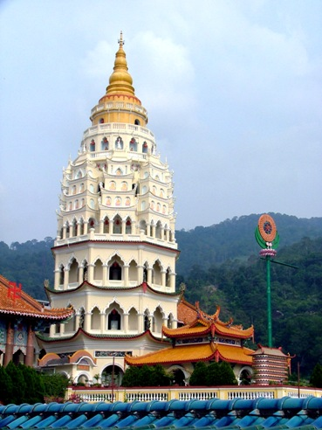
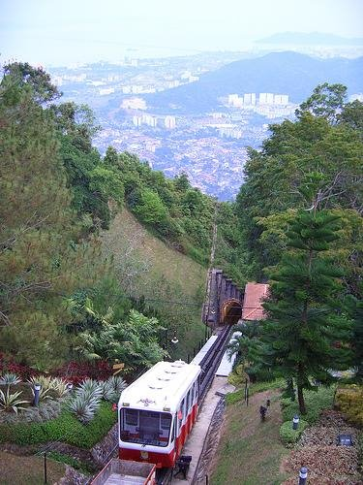

Penang Hill and Botanical Gardens

If you need some respite from the heat and ceaseless activity of the city, head for the 30-hectare Botanical Gardens famous for their 100-metre high waterfall and affable rhesus monkeys. The Gardens adjoin Penang Hill, the island's chief hill station towering 830m above sea level. Visitors can reach the top by either hiking the marked track (approx. four hours) or more popularly by taking the funicular railway (RM4). The elevation and shade afforded by the tropical canopy create a cool, refreshing climate.

Beaches

Penang isn't purely a sun, sea and sand destination but the beaches are fantastic and the water calm and clean. The best beaches are located on Penang's northern shoreline where stretches of golden sand are interrupted only by secluded coves and an increasing number of international-style resorts. The most popular beaches are undoubtedly Tanjung Bunga, Batu Ferringhi and Teluk Bahang, while more privacy can be had at Monkey Beach and Pantai Mas, the latter located in its very own forest reserve.

The Snake Temple

The Azure Cloud Temple of Penang dedicated to Chor Soo Kong, is more popularly known as the Snake Temple - and it's not hard to see why. From the outside the structure seems a pretty standard Buddhist temple, but on entering you'll find it literally festooned with snakes of all kinds. These range from the harmless to the deadly pit vipers, and according to the local hangers-on (who spend their time taking photos of tourists wearing rictus grins on their faces and vipers round their necks) none of them have been tamed or had their fangs drawn. Nobody has been bitten in the history of the temple, but there's always a first time, so watch where you tread. Many people believe that the thick clouds of incense render the snakes sleepy and harmless while the Buddhists believe the snakes are the embodiment of protective spirits. Located near to the airport on Bayan Lepas Rd.

Open: daily 0700 hrs – 1900 hrs

CAMERON HIGHLANDS
The Cameron Highlands, in the centre of Peninsular Malaysia, comprise a series of hill stations at altitudes between 1500 and 1800m (4920 and 5904ft). This fertile area is the centre of Malaysia's tea industry and it's the place where locals and visitors come to escape the heat of the plains. Attractions include jungle walks, waterfalls, tours of tea plantations, beautiful gardens and plenty of wild flowers. The cool weather tempts visitors to exertions normally forgotten at sea level, like golf, tennis, and long walks, but this is really Malaysia's R 'n' R capital par excellence for those who don't like the beach and enjoy a bout of colonial nostalgia. Most of the budget hotels are in the village of Tanah Rata. The more expensive options are scattered between Tanah Rata and Brinchang.

TIOMAN ISLAND
This picture-postcard island lies off the eastern coast of Peninsula Malaysia in the South China Sea. It boasts beautiful beaches, clear, coral-filled water, technicolour marine life, virtually unpopulated jungle highlands, crystal-clear streams, and the dramatic peaks of Batu Sirau and Nenek Semukut. Tioman has been blessed with exotic place names like 'Palm-Frond Hill' and 'Village of Doubt' and is generally quoted as the setting for the mythical Bali Hai in the film South Pacific. The permanent population on Tioman is low, and locals are usually outnumbered by tourists. June and August are the peak tourist months, but during the heavy November to January monsoon the island is almost deserted.
The island's West Coast is dotted with villages and is home to a classy resort. Pulau Tioman is the most popular travellers' destination; Kampung Nipah is the place to go if you really want to get away from it all. You can get to Tioman by boat from Mersing and Singapore. The island's largest village, Kampung Tekek, has an airstrip.

LANGKAWI
Langkawi consists of a group of around 100 islands. While most are uninhabited, a few have been designated for tourism development so that visitors from all over the world can admire and appreciate the magical beauty of Langkawi.

Langkawi Cable Car

Langkawi Cable Car gives an experience of the historical, natural and other unique places of interest. Located at the southwest coast of the main island, just a 30 minute drive from Kuah Town and only 15 minutes from Langkawi International Airport. With three different stations located at different heights is an adventurous experience itself. The base station conveniently located within themed shopping center known Oriental Village at the foothill of Gunung Mat Chinchang. One can be spoilt for choices in shopping bargains and for the more adventurous singles, trekking up the hils into the wilderness and coming face to face with the many geological features along the route.

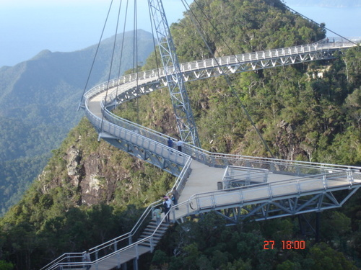
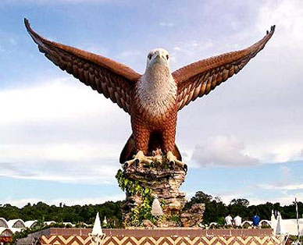
For the fun lovers, the top station awaits with a warm welcome where one could get soaked up the sun, absorb the fun while romancing and fascinating the feel of the magic on the air.

Underwater World Langkawi

Underwater World Langkawi is one of the largest marine and fresh water aquaria in South East Asia. The concept and theme of Underwater World Langkawi are geared towards Knowledge, Education and Entertainment. It is built to raise awareness on the importance of conserving our precious aquatic life forms, thus creating understanding of the deep and inseparable bond between man and nature.

Unique to Underwater World Langkawi is the gigantic 15-meter long walk-through tunnel consisting of 500,000 liter seawater which houses many big fishes and sea creatures including the Giant Green Turtle. Other attractions include the Freshwater Fish Section, the Seashell Display, the Koi Pond, the Mini Reptilian and Invertebrate Section, the Coral Reef Section and the Poisonous and Venomous Creatures Section.

A new building (with 60,000 sq. ft built-up area) which displays Tropical Rainforest, Temperate and Sub-Antarctic Ecosystems, and a three-dimensional (3D) theatre with a 200-seating capacity will be opened to the public in early 2005. The Sub-Antarctic Ecosystem Display includes a spectacular “penguinarium” with an underwater tunnel for visitors to view swimming penguins.

Snake Sanctuary

A Beautiful Parkland with an undulating setting is home to this collection of venomous and non-venomous snakes from all over the world.

Seven Wells
Located at Burau Bay, on the slopes of Mt. Cincang, these 91 meters high seven level waterfalls are truly spectacular and are a must-see for all nature lovers.

The Lake of the Pregnant Maiden

This lake is a must on your itinerary with its fascinating, geological features and mysterious legend and mood. It is believed that barren women who drink from this lake will conceive.

Mahsuri Mausoleum

This marks the spot where Mahsuri lies buried. It is situated in a village amidst padi fields and is made of beautiful marble. It also bears testimony to the powerful effect Mahsuri had and still has on this island. A village house on stilts, documenting the family history of Mahsuri, as well as displaying lifestyles of 'historical Langkawi', like ancient tools, artifacts and music can be found on the grounds of the Mausoleum.

Air Hangat

The spot where the hot water spilled onto the ground turned into a hot spring -- an occurrence that defies geological explanation. 'Air hangat' or hot water is the name appropriately given to the area which survived to this day. The hot spring itself has long been revered by folks in Langkawi as a venerable fountain of myriad cures.

TAMAN NEGARA NATIONAL PARK
Accessible only by boat offers a rare opportunity to visit one of the most pristine primary rainforests in the world. The park covers 4343 sq. km (2693 sq. miles), sprawling across Pahang, Kelantan and Terengganu. The wildlife is varied and abundant, but more evident on extended treks or boat trips away from the more frequented areas.

SARAWAK
Sarawak offers ever-shrinking areas of untouched jungle, the chance to visit longhouse-dwelling Dayak tribes and a good system of national parks. The area around the capital city, Kuching, has remote coastal villages, such as Pandan and Sematan, and unspoilt tropical rainforest, beaches and walking trails in the Bako National Park. Longhouses are found along the Rejang River and its tributaries - central and southern Sarawak's 'highway'. The areas downriver from Kanowit and Song are generally less frequented. In the north-east, the Niah Caves, accessible only by longboat and a 3km (1.86mi) hike, are unforgettable for their rock paintings, forest wildlife, jungle trails and night walks to see the luminous mushrooms. Visitors to Sarawak cannot fail to notice the extent to which logging is affecting the environment and the habitat of the Dayak tribes. Acquainting yourself with the issues surrounding Malaysia's logging practices is recommended before visiting the province.

SABAH
Scenic grandeur and fascinating wildlife are the main attractions in (expensive) Sabah. Just offshore from the capital, Kota Kinabalu, the huge Tunku Abdul Rahman National Park (4929ha/12,174ac) is made up of the islands of Gaya, Mamutik, Manukan, Sapi and Sulug. The islands have some of the best beaches in Borneo and wildlife varies from monkeys and bearded pigs to corals and tropical marine life.
Not far from the Kalimantan border, Batu Punggul has an adventure-camp resort, jungle walks, canoeing and cave visits. The resort is accessible only by boat, and the area is home to many longhouse-dwelling tribes. North of the capital, Kota Belud is the venue of one of Sabah's largest open-air Sunday markets and get-togethers (called a amu). It attracts all manner of vendors, selling everything from magic pills to cattle.
Inland, Mt Kinabalu is one of Sabah's major attractions. It's one of the easiest mountains in the world to climb and the views from the top are sensational - especially at sunset.
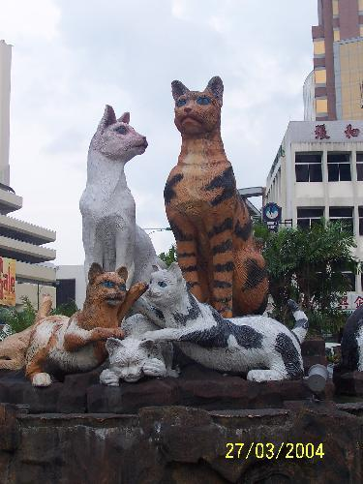
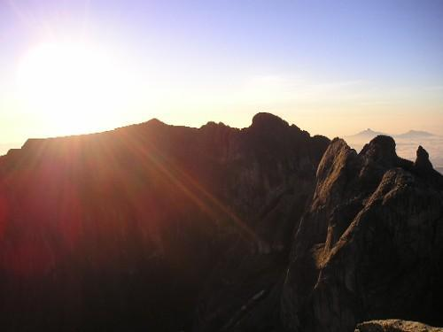

LIST OF INDIAN RESTAURANTS

Kuala Lumpur

- Annalakshmi
G(E) - 017, Ground Floor,
(Boulevard) Mid Valley Megamall,
Lingkaran Syed Putra,
59200 Kuala Lumpur, Malaysia
Tel: 00 6 03 2284 3799 /
00 6 03 2284 0799

- Bombay Palace
388 Jalan Tun Razak,
Kuala Lumpur,
Malaysia
Tel: 00 6 03 2145 7720

- d'Tandoor
63-65G, Jalan SS 21/60,
Damansara Utama,
47400 Petaling Jaya,
Selangor, Kuala Lumpur,
Malaysia 47000
Tel: 00 6 03 7728 2020 /
00 6 03 7727 3352

- The Taj
City Square Centre,
Jalan Tun Razak,
Crown Princess Hotel,
Kuala Lumpur, Malaysia 50400
Tel: 00 6 03 2162 5522

- Sri Rekha
39 Jalan Sultan Ismail,
50250 Kuala Lumpur,
Malaysia
Tel: 00 6 03 2145 4339

- Spice Garden
205 Jalan Bukit Bintang,
55100 Kuala Lumpur,
Malaysia
Tel: 00 6 03 2141 2220 /
00 6 03 2141 2223

Langkawi

- Papadam Restaurant
Pantai Cenang
Langkawi

Genting Highlands

- Kampong Restaurant
First Floor, Resort hotel
Genting 69000
Genting Highland

- Spice Garden Restaurant
H/G Unit 6.00, Ground Floor,
Highlands Hotel,
69000 Genting Highlands,
Pahang Darul Makmur

Penang

- Madras New Woodlands
Penang Street, Penang,
Tel. 04 2639764

- Komala Vilas
No. 55, Penang Street, 10200 Penang,
West Malaysia, Tel: 04-2639731
Malacca

Malacca

- Restoran Veni
34, Jalan Temenggong,
Malacca Central 75000,
Tel. 06 284-9570

- Banana Leaf
40 A, Jalan Munshi Abdullah 75100,
Tel. 06 283-1607

Kota Kinabalu

- Jothy's
1G9 Block 1 Api-Api Centre 88804,
Tel. 088 261-595

Kuching

- Curry House
Lot 409, Section 10,
Lorong 3A,
Rubber Road

